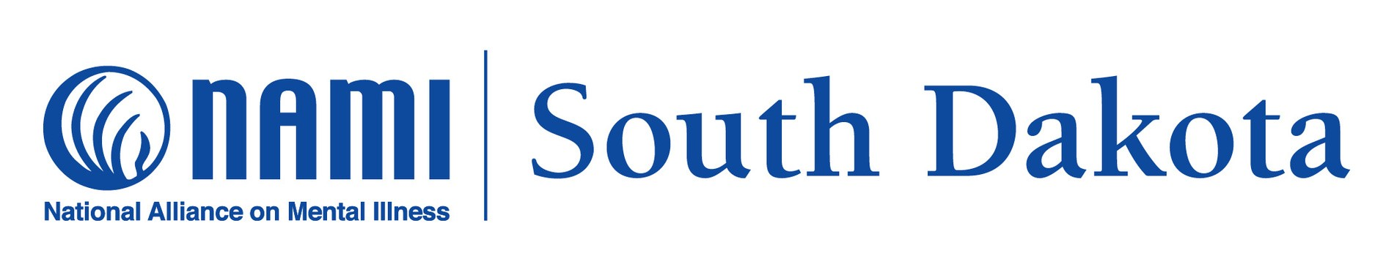
NAMI South Dakota is a non-profit organization dedicated to improving the lives of
persons affected by mental illness.
Phone Numbers: 605-271-1871

Online Resources Available
Please go to our website or Facebook page for more information
or to register.
www.namisouthdakota.org

Support Groups
NAMI Connections Support Group
Every Wednesday 5:30-6:30pm (CST) Every
Thursday noon-1pm (CST)
NAMI Family Support Group
1st & 3rd Sunday 6:00-7:00pm (CST)
Presentations
-NAMI Ending the Silence
A presentation that teaches students, staff,
and parents about the warning signs of
mental health conditions and offers resources
on how to help a friend.
-NAMI In Our Own Voice
A presentation led by two adults living with a
mental health condition who share their story
about recovery.

NAMI In Your Community

Local support groups, education classes, and wellness activities are available in-person.
Please check out namisouthdakota.org to find a NAMI local affiliate for all in-person activities.

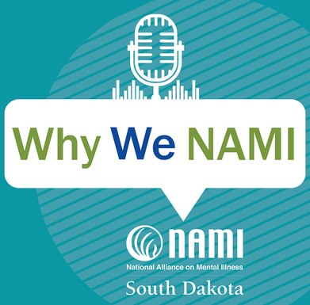
Listen to our weekly
Why We NAMI podcast on your favorite podcast app or at namisouthdakota.org

Education Classes
-NAMI Basics
A free, 6-class education program for parents and caregivers of children and teens who are experiencing symptoms of a mental illness or who have already been diagnosed.
-NAMI Family-to-Family
A course designed for loved ones of adults
who have been diagnosed with a mental illness.

Wellness Activities

We have a variety of online wellness activities each month. Some include:
- Story Stitch
- Wellness Breath Sessions
- Wellness Writing Workshops
To see a list and register for NAMI SD wellness activities go to www.namisouthdakota.org or the NAMI South Dakota Facebook page.

Additional Resources
Helpline
Dial 988

NAMI Helpline
1-800-950-6264
NAMI Texting line text NAMI to 741741

